1. Design DFA to accept bcaaaaaaaaaaaaaa, bc, and c

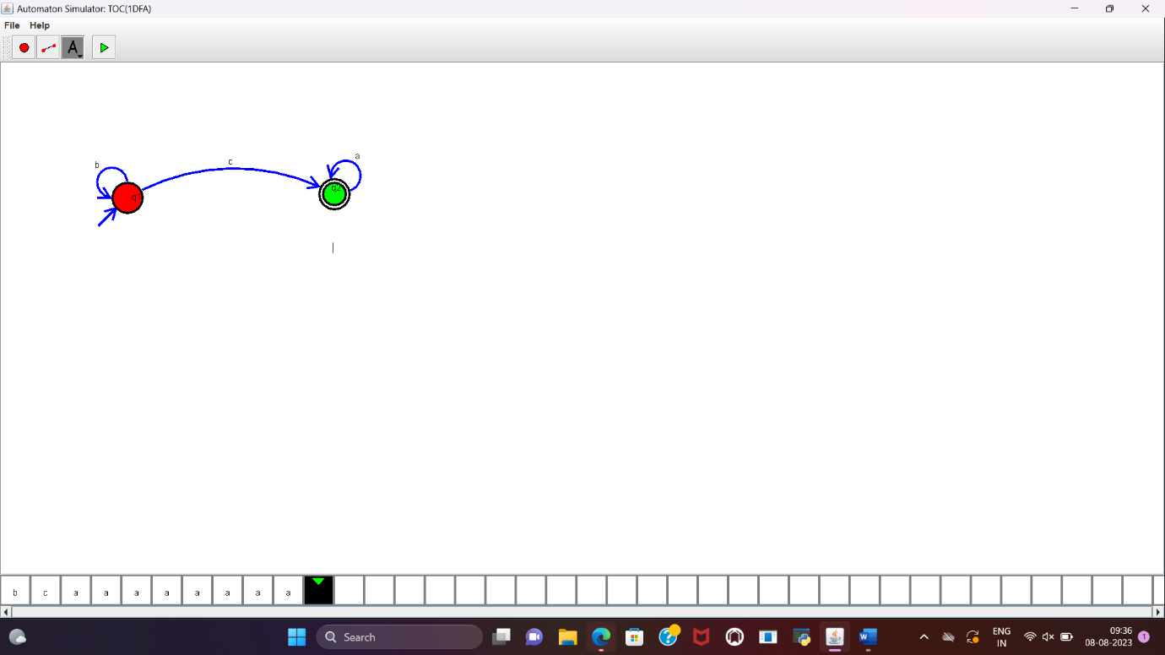

2.Design NFA to accept aaaaaa

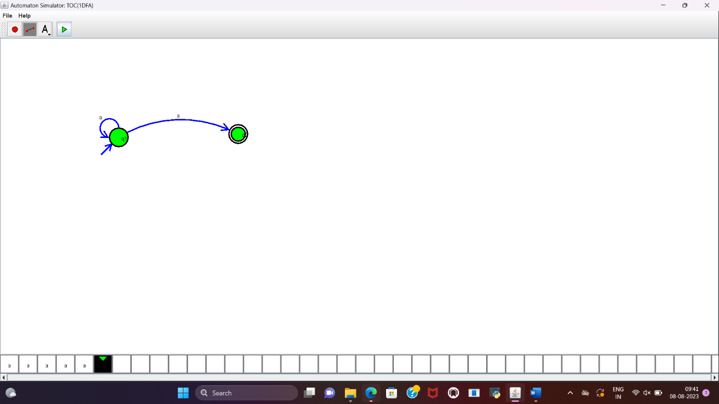

3.Design PDA for the input a^nb^n

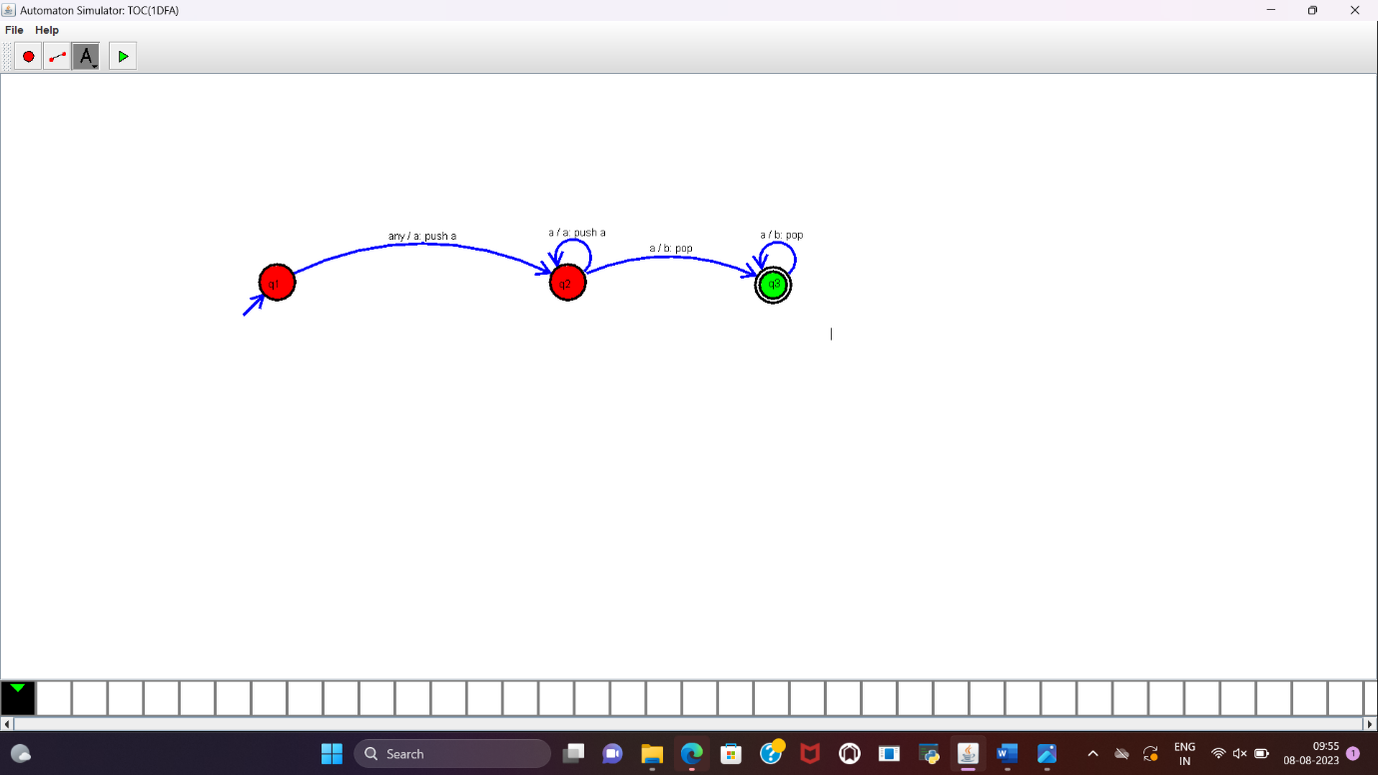

4.Design Tm For input a^nb^n

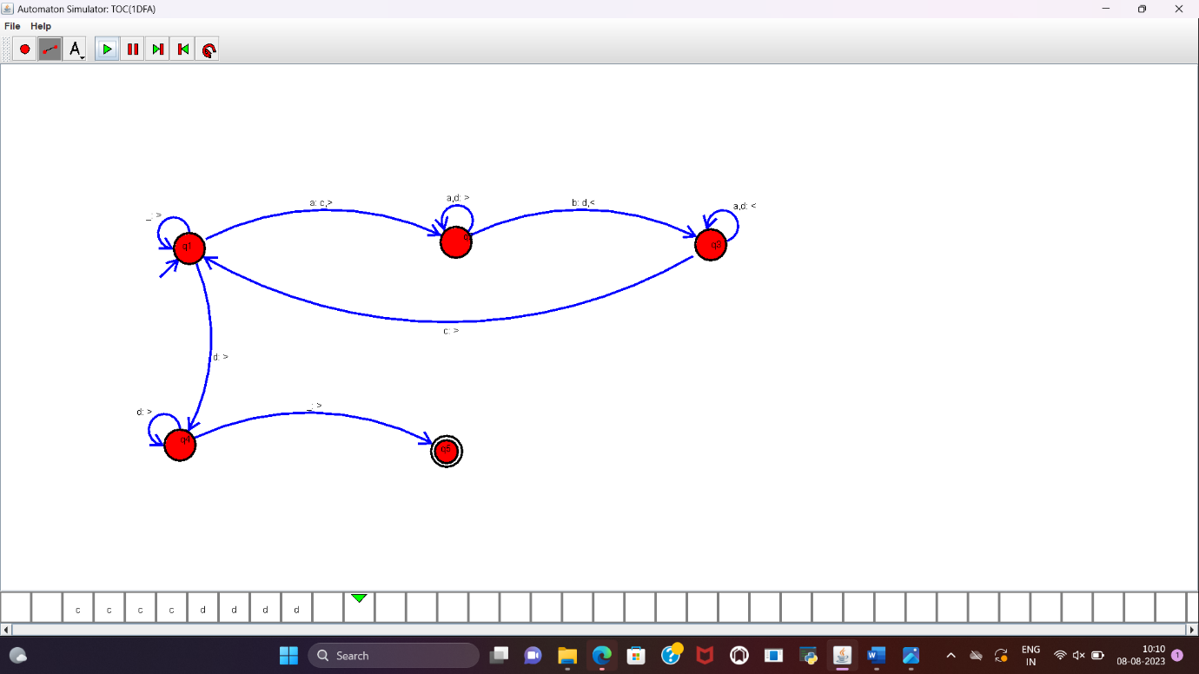

5 .Design PDA for input aabbbbc ( L=a^nb^2n)

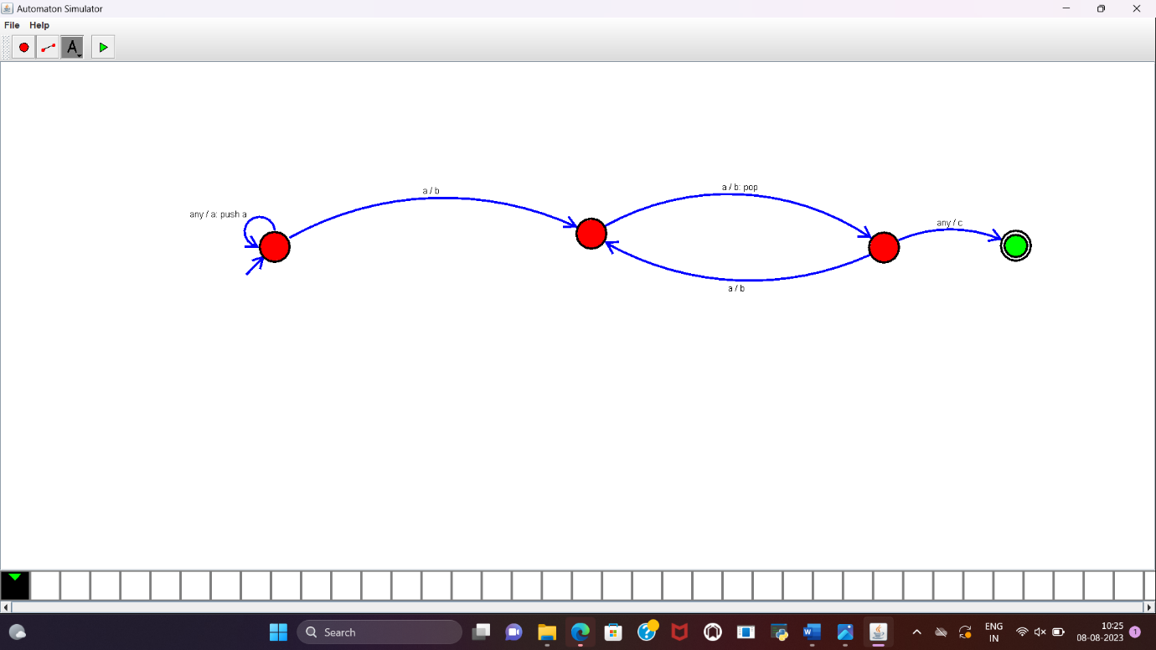

6.TM Simulation for Palindrome W= ababa c7.Design TM to perform addition of following

W= aa + aaaa

After Addition of a’s = aaaaaa

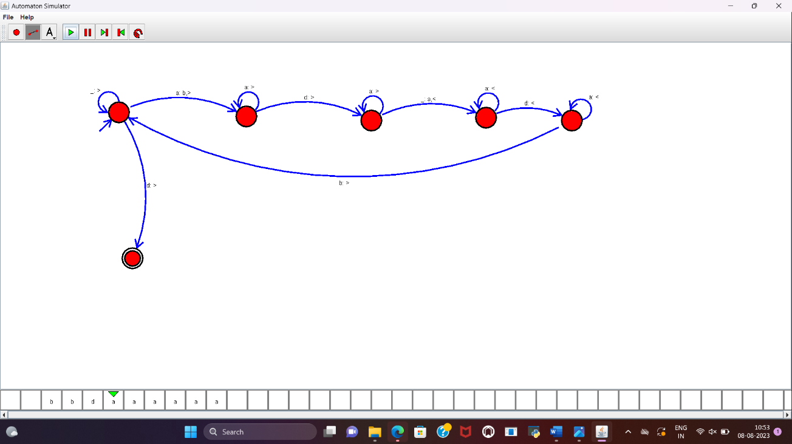

7. Design TM to perform subtraction

W= aaa-aa

The Result of Subtraction is = a

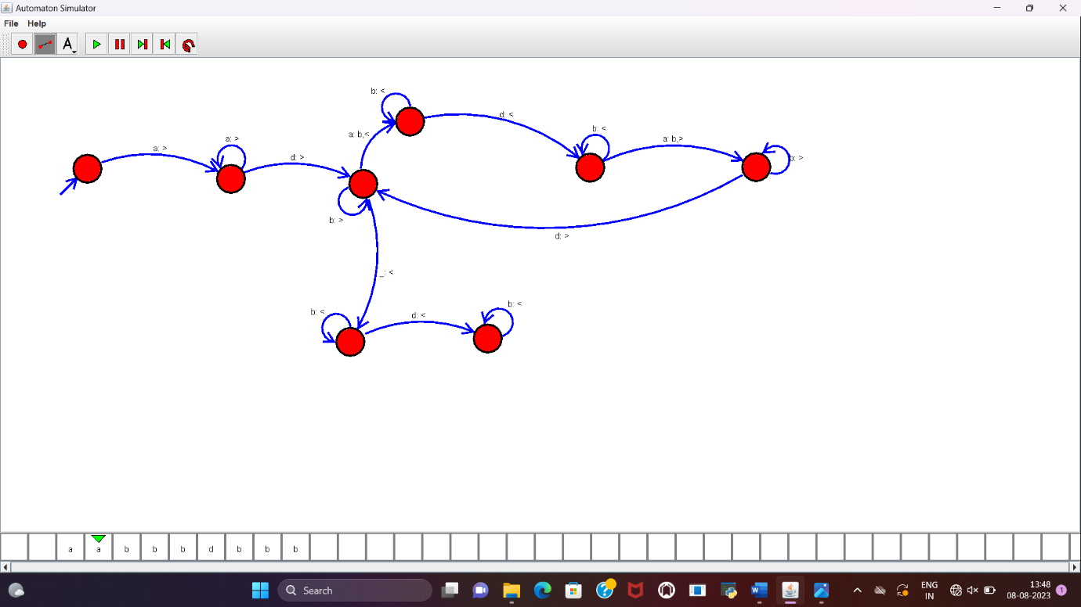

8. Design TM to perofrm string comparison

W = aba aba

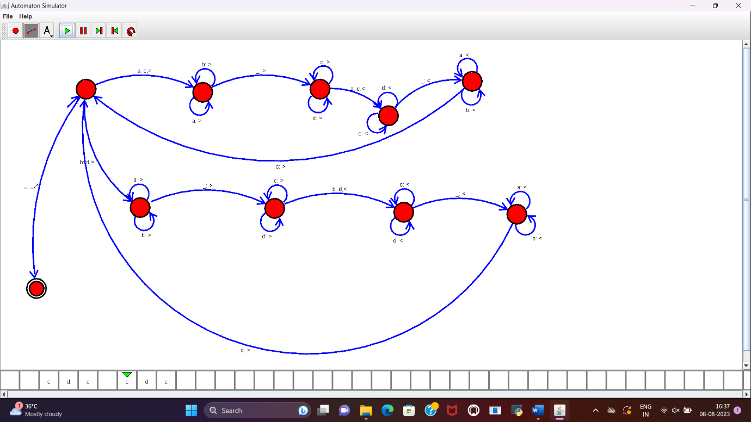

9. TM Simulation for Palindrome W= ababa c

